Accommodation

Hotel | Price per room, per night
Hotel | Single room | Double room
VITOSHA HOTEL 4* | € 60 | € 80
PARK HOTEL MOSKVA 3* | € 48 | € 66
HEMUS HOTEL 3* | € 38 | € 56
HOTEL – CLUB INFORMA 1* | € 22 | € 32
The above rates are inclusive of breakfast, city tax and hotel insurance, and are valid only for direct payment to CIM Ltd.
Deposit of one night is required in confirmation of the hotel reservation. For your convenience it is possible to prepay the total amount of the hotel accommodation.

Upon request CIM Ltd can arrange lower or higher hotel category.

For more information about the hotel accommodation, please contact us on:
Tel. (+359 2) 980 73 16; 986 08 06
Fax (+359 2) 980 60 74
E-mail: cim@cim-pco.org

Cancellation policy
Only written cancellation will be considered. A refund of payment less 10 % administrative charges will be made for cancellations received by 1 August 2008.

Vitosha Park Hotel

The four stars Vitosha Park Hotel is situated in the south area of Sofia, close to the airport and within walking distance (approximately 5 minutes) from the University of Chemical Technology and Metallurgy. The vicinity of the nearby park and the unique view on Vitosha Mountain give a sense of comfort and relaxation.
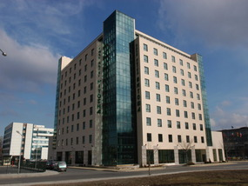

The hotel offers 164 cozy rooms and apartments. Each room has direct dial telephone, satellite/ cable TV, radio, internet access, mini bar, bathtub.
A nice feature is the mini kitchen bar in every room.

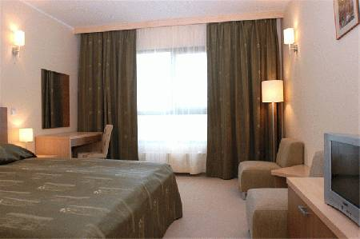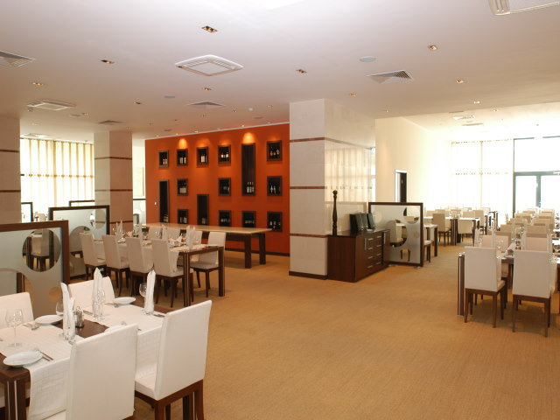

The hotel has spacious fitness center and a swimming pool, free of charge for the hotel guests, laundry, dry-cleaning, rent-a-car, business centre, copy centre, secured parking lot, souvenir shop, etc. The elegant “Toskana” restaurant offers selected dishes from the Bulgarian, Italian and international cuisine.
Check in 2:00 PM
Check out 12:00 PM

Park Hotel Moskva

Park Hotel Moskva is situated in the most beautiful and green part of Sofia – the Borisova garden. The hotel withstands at a convenient, equal distance from the capital’s administrative center, Sofia Airport and the main city hotspots. The University of Chemical Technology and Metallurgy could be reached by bus No 413.
The hotel offers recently renovated single and double rooms, luxury business rooms, small (1 bedroom) and large (2 bedrooms) apartments with luxurious bathrooms, cable television, internet access, automated telephone service and mini-bar.

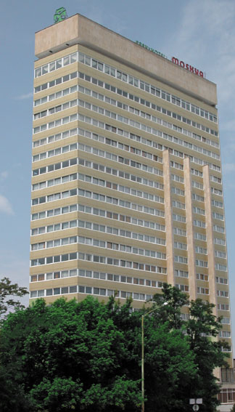

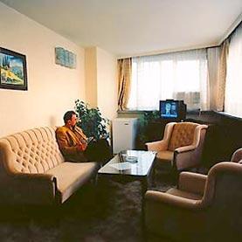

In the restaurants you can enjoy the best of Bulgarian and European cuisines. There is also a casino, lounge bar, coffee shop, night club, lobby bar, conference rooms. Other hotel facilities include: guarded parking, fitness, sauna, safe deposit boxes, information and money exchange, room service, laundry and dry cleaning.

Check in 2:00 PM
Check out 12:00 PM

Hemus Hotel

Centrally located, recently renovated, three–stars hotel with an incredible panorama view to the Sofia City Center from the northern side and to the Vitosha mountain from the southern. The hotel is located next to the National Palace of Culture, near the administrative and cultural center of the capital. The University of Chemical Technology and Metallurgy

could be reached by bus No94 from National Palace of Culture.

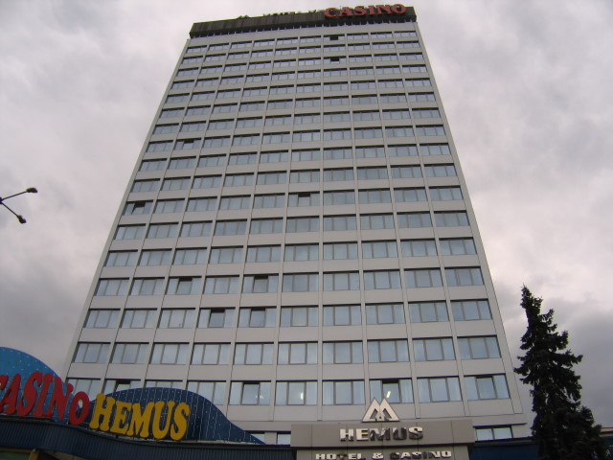

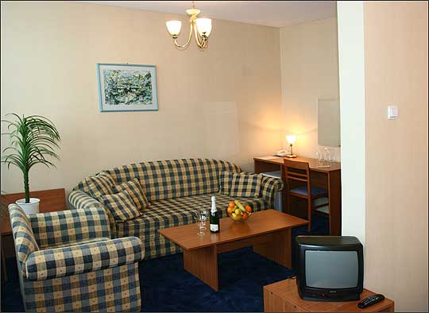

The hotel offers 125 double and 45 single rooms, each well appointed with a writing desk, direct dial telephone, satellite TV, private bathroom with shower.
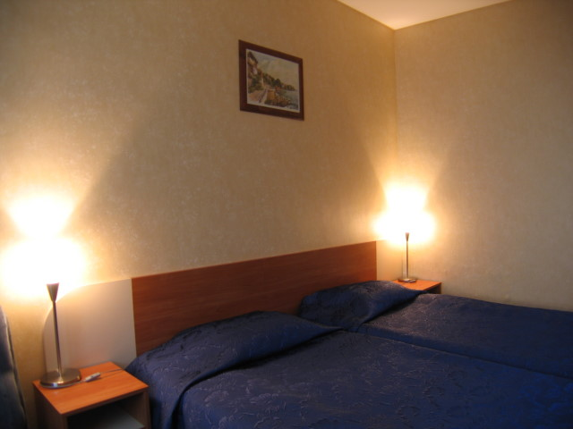

The hotel has restaurants and bar, coffee and pastry shop, nightclub, hairdressers, souvenir shop, air tickets office and parking place. For guests' convenience safety deposit box and valet services are offered.

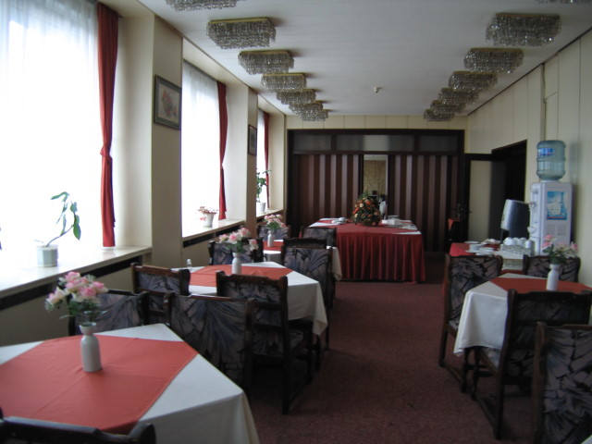Check in 2:00 PM
Check out 12:00 PM

Hotel – Club Informa

Hotel-club Informa is one star hotel located in “Student town” - the district with most universities in Sofia. Not far from the foot of Vitosha mountain with great mountain view, at just 7 km from the city center and 10 km from Sofia airport.

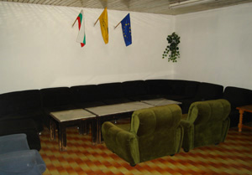

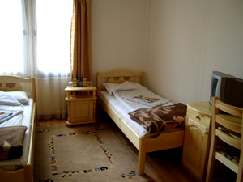

The Hotel-club Informa offers 80 beds in 30 rooms with two and three beds and 5 suites. The rooms are furnished with TV set with cable channels, refrigerator and telephone.

Next to the hotel there is a sport center (tennis court, fitness center, swimming pool, sauna, football, basketball and volleyball playgrounds). There is also an internet center nearby.

Check in 2:00 PM
Check out 12:00 PM

